Bexhill bathing water investigation
Project Brief

Background
Bexhill bathing water has been the focus of a wide range of investigations over the past 3 years including the Bathing Water Enhancement programme (BWEP). The purpose of these investigations was to investigate factors that could contribute to a deterioration in water quality, this included investigating the condition of the Southern Water sewer network and assets in the area.

A culverted watercourse runs from the top of the catchment down to an outfall, close to the EA bathing water sampling point. In addition, there are surface water sewers in high-risk locations close to the sampling point which could carry other forms of pollution from the highway and other sources. Investigations have included monitoring these assets using a range of techniques to identify evidence of misconnections from domestic or business properties.

To date, there has been no clear evidence of a pollution, however, the bathing water quality has gradually deteriorated in Bexhill following several samples exceeding acceptable levels of E. coli and Intestinal enterococci (IE).

This season (2022) has seen bathing water classification in Bexhill deteriorate further, based on the pattern of sample results collected by the Environment Agency over the past 4 years. There is now a very real risk of achieving poor classification which could have a damaging impact on tourism to the town.

As such, there is a need to explore a full and detailed survey of the Bexhill coastline and inland sections of un-culverted watercourse (upstream of Egerton Park) for active Southern Water outfalls and identify other unknown assets, not shown on our mapping. This could be a crucial activity to enable us to determine whether there are any factors outside of our control that may be contributing to the deteriorating bathing water quality.

Regular stakeholder meetings are taking place to identify risks and develop a plan to mitigate areas of concern to build a more positive set of results in the future

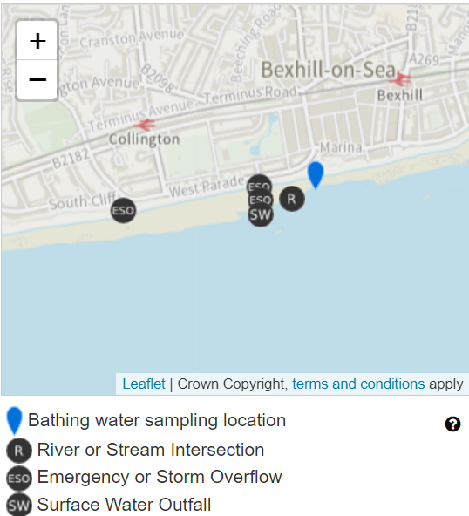

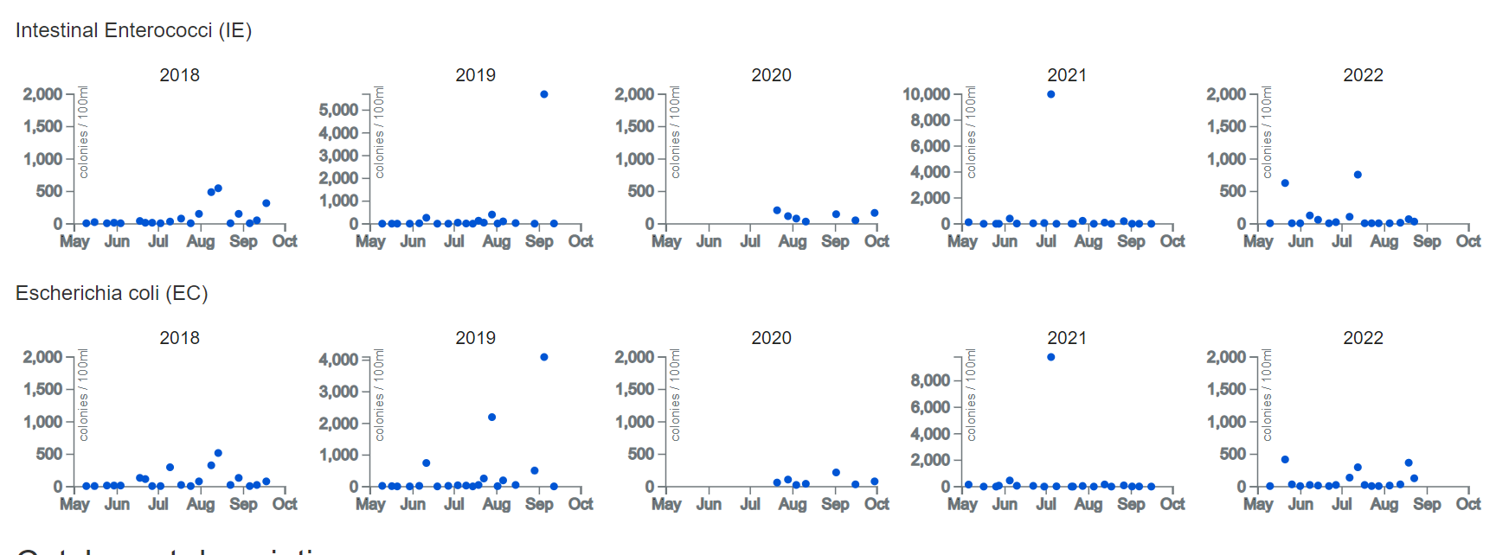

Survey brief
A survey is to be undertaken along the Bexhill coastline and the inland river comprising of culverted section and open section of watercourse. The coastline is approximately 6.5km whereas the river is approximately 2.5km and splits into two waters in the upper Bexhill Catchment. Adler and Allen survey team are to be instructed to search for any pipes that are noticed when carrying out walkovers in the key areas and then sample for bacteria and chemical based pollutants

The results of the investigation will be shared with Southern Water to investigate high bacteria samples from the surface water network or trace the source of any unknown pipes to the source

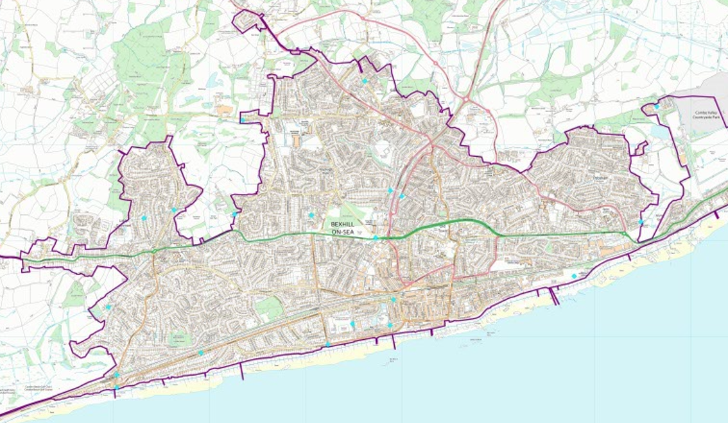
Map of Bexhill coastline

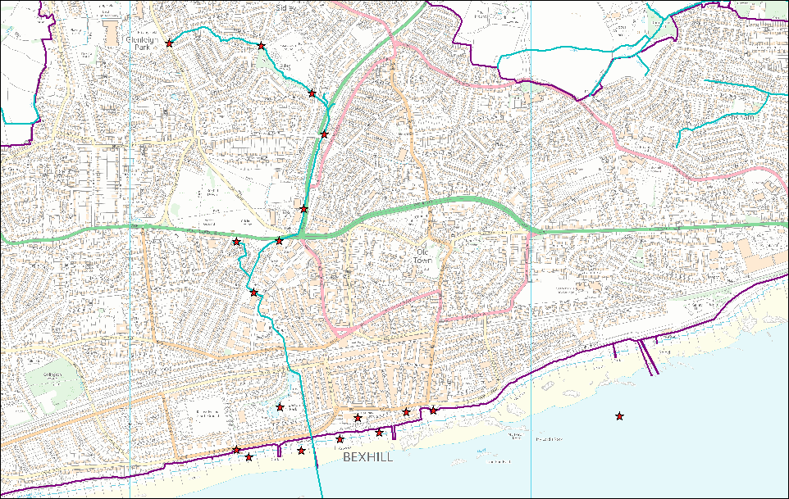

River sample area map

Outfall assessment

Each outfall the team encounter will be surveyed, and observations recorded, including photos as well as samples taken from live flow from the asset. Differing monitoring equipment will be required for assess the levels of bacteria in the coastal saline conditions and fresh water in the upstream catchment.

The findings will be shared with Southern Water in the standard report form. The findings will then allow further investigations by Southern Water to determine the source of the pollution.

